LIST OF HANDS-ON ACTIVITIES IN MATHEMATICS
FOR CLASSES III TO VIII

Mathematics Laboratory

The concept of Mathematics Laboratory has been introduced by the Board in its affiliated schools with the objective of

- Making teaching and learning of the subject interactive, participatory, funfilling and joyful from primary stage of schooling.

- Strengthening the learning of mathematical concepts through concrete materials and hands-on-experiences.

- Relating classroom learning to real life situations and discourage rote and mechanical learning.

The Board has already published detailed guidelines for Mathematical Laboratory in schools for class IX and class X including hands-on activities to be done during these academic years.

Given below is the list of activities to be done by the students in classes III to VIII during each academic year.

CLASS 3

Activity 1: To draw the following on a dot paper (i) a hut (ii) a joker (iii) a flower

Activity 2: To represent the following pair of numbers on straight lines, using
stickers. Also find the greater number from the representation
(i) 7 and 11 (ii) 9 and 5

Activity 3: Group Activity: Body Mathematics

Divide the class in groups of 5 students (say)

Using a measuring tape ask each group to measure the following
- Length of the right palm
- Width of the right palm
- Length of the right ear
- Width of the smile

Ask them to note down the following observations:

- Which group member has longest palm length?
- Which group member has shortest palm length?
- Which group member has widest smile?
- Which group member has longest ear length?
- Which group member has shortest ear length?

Activity 4: To measure the dimensions of door or window of room in your house using a 1 m long thick thread?

Activity 5: a) To count the edges and corners of the following objects
i) Ruler ii) Rectangular paper iii) Dice iv) Shoe box
v) Alphabet ‘O’

b) Fold a rectangular paper from each corner one by one and record the
number of edges and corners obtained after every step.

Shape | No. of edges | No. of corners
Rectangle
After folding 1st corner
After folding 2nd corner
After folding 3rd corner
After folding 4th corner

c) Fold a paper five times in any way. Unfold and draw any shape on the creases formed. Record the number of edges and corners of the shape drawn.

Activity 6 : To make the following shapes using tangram pieces
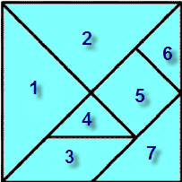

i) a cat ii) Numeral 4

Activity 7: To make a time scheduler from wake up time to bed time on a working
day and a holiday.

Activity 8: To represent multiplication tables, from 2 to 5, using lines and dots by an activity method. (Use stickers to represent dots)
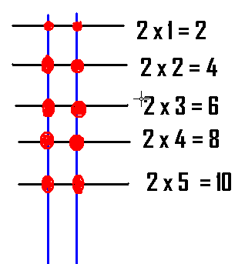

Activity 9: To identify a number as an even number or an odd number, by making
pairs of beads/ pebbles/counters.

Activity 10: To experience money transactions using fake notes and coins

i) Rs. 20 note = four Rs. 5 notes/ coins
ii) Rs. 20 note = two Rs. 10 notes
iii) Rs. 20 note = ten Rs. 2 coins
iv)Rs. 20 note = twenty Rs. 1 coins

CLASS 4

Activity 1: To draw the following on a dot paper
- triangle
- square
- rectangle

Activity 2: (a) To find the centre of a circle by paper folding and verify that
length of radius of the circle is always same.
(b) To make a geometrical design using compass and a ruler.
(c) To make a pattern of different circles with
i) same centre and different radii
ii) same radii and centre’s on the same line

Activity 3: Do the following by paper folding
- Transform a square into
- four rectangular quarters
- four square quarters
- four triangular quarters

- Transform a rectangle into
- four rectangular quarters
- four triangular quarters

Activity 4: To mark ¼ m, ½ m and ¾ m on a string of length 1 m.

Activity 5: (Hand Print Activity)

- To shade 1/4th region of your palm print.
- To make patterns using thumb prints.

Activity 6: To make a repeated tiling pattern on a dot paper , using geometrical shapes
as tiles.

Activity 7: (a) To write a secret code message if all the English alphabets are replaced
by numbers from 1 to 26 ,respectively ,in order.
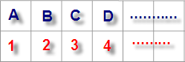

(b) To decode the given message on the basis of above code.

9 12 15 22 5 13 25 9 14 4 9 1

Activity 8: (a) To find the length of the boundary of the top of mathematics text
book in (cm) using a thread.
(b) To find the length of the boundary of any shape in (cm) drawn on a paper
using thread.
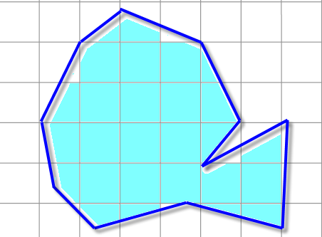

Activity 9: To write your name using tangram set.
Note: Teacher may ask the students to cut tangram pieces using the given
diagram. Make duplicate copies of it.

Activity 10: (Group Activity)
Divide the class in the groups of 5(say) and perform the following activities in each group.

- Measure the height of each member in cm(s) using a measuring tape.
- Measure the weight of each member in (kg) using a weighing machine and answer the following.
- Who is the tallest member of your group?
- Who is the shortest member of your group?
- What is the maximum weight measure in your group?
- What is the minimum weight measure in your group?

CLASS – 5

Activity 1: To make a set of tangrams by paper folding using 8x8 grid.

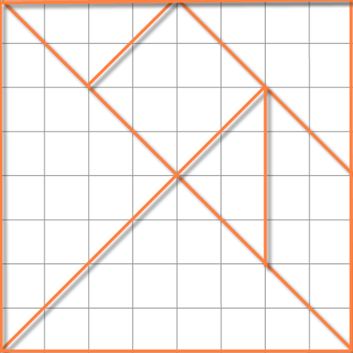
Using the tangram pieces do the following:

  - Try to make a triangle, a square and a rectangle using 2 pieces of the tangram set.
  - Try to make a triangle, a square and a rectangle using 3 pieces of the tangram set.
  - Calculate the area of each part by counting complete squares and half squares.

Activity 2: (a) To make closed geometrical shapes using
- 3 match sticks
- 4 match sticks
- 5 match sticks
- 6 match sticks

(b) To observe the change in angles between any two adjacent match sticks.

Activity 3: (a) To identify a right angle, angle less than a right angle and angle more than a right angle using body parts and to draw them using stick drawings.

- Write the word mathematics using straight lines and observe the number of right angles, number of angles more than a right angle and number of angles less than a right angle.

- To make a degree clock by paper folding.

Activity 4: To observe hands of the clock at different time in a day and record four observations each of the following

- right angle between hands of the clock
- angle less than a right angle between hands of the clock.
- angle more than a right angle between hands of the clock.

Activity 5: (a) To make rectangles of different dimensions on a squared paper using 12
adjacent squares.

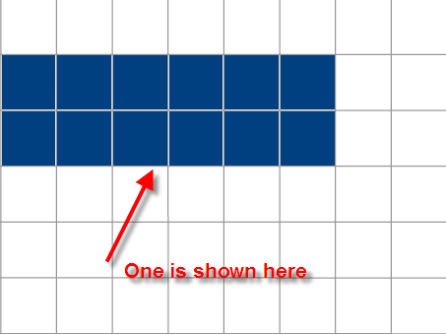

(b) To calculate the perimeter and area of each of the rectangles so formed.

(c) To observe the fact that shapes having same area may have different perimeter.
(d) To observe the relation between dimensions of rectangles and the factors of
12.
Activity 6: To calculate the perimeter of different shapes formed by shading six adjacent squares of dimension 1 cm each on a squared paper.
Some shapes are shown below

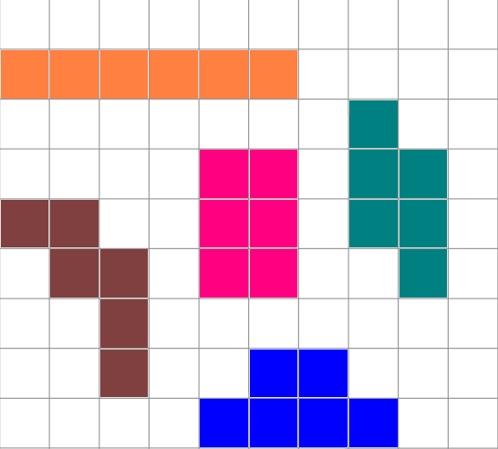

Activity 7: (a) To represent the fractions ½, 1/3 , ¼, 1/5, etc. using rectangular strips of papers by paper folding.

(b) To represent the fractions ½ , ¼ , ¾ , 3/8 , 5/8 etc. of a circular region by paper folding.

Activity 8: To find the lines of symmetry in the following shapes by paper folding

  - a square
  - a rectangle

Activity 9: To make a 3x3 magic square, using numbers from 1 to 9.
Hint:
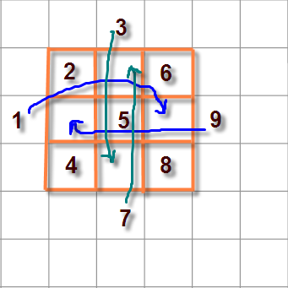

Activity 10: (a)To make cube and cuboids of various dimensions using unit cubes
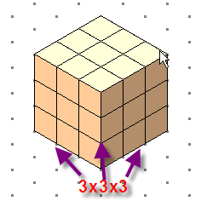

i) 2x3x2 cubic units
ii) 3x3x2 cubic units
iii) 3x3x3 cubic units

(b) To find the number of missing unit cubes in a given shape to obtain a
given shape of desired dimension .

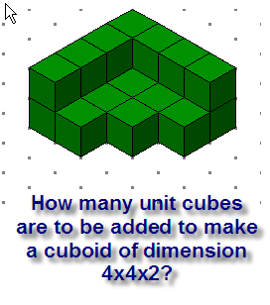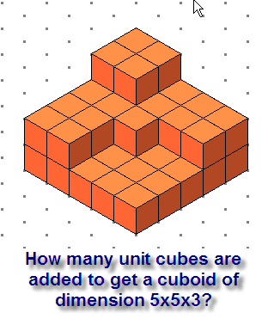
Note: Teacher may ask the students to use unit cubes and explore.
CLASS – 6

Activity 1: (a) To verify that addition is commutative for whole numbers, by paper cutting and pasting.
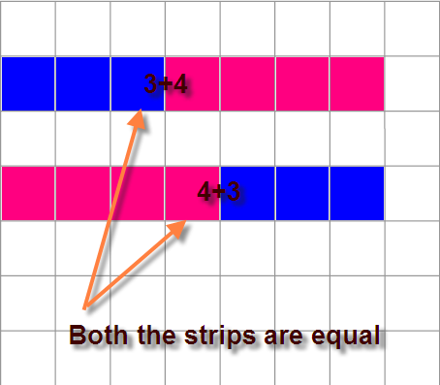

(b) To verify that multiplication is commutative for whole numbers by paper cutting and pasting.
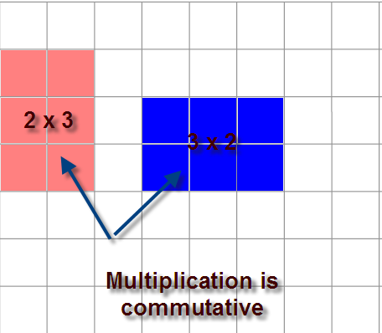

Activity 2: To find prime numbers from 1 to 100 by Eratosthenes Sieve’s method.

Activity 3: (a) to make a cube using the given net and count the number of faces, vertices and edges.
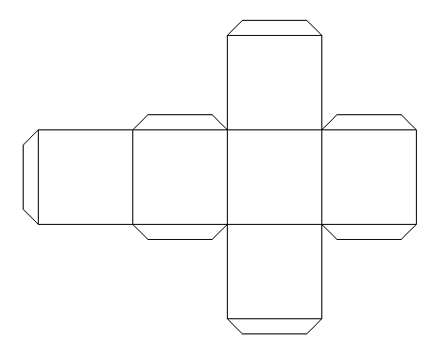

3 (b) To check which of the given nets can be folded to get a cube.
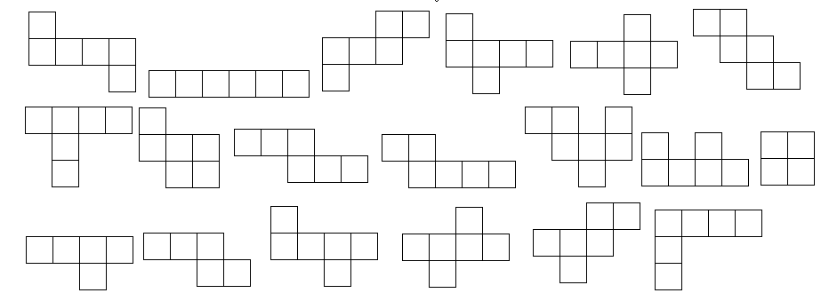

Activity 4: To find the HCF of two given numbers by paper cutting and pasting.

Activity 5: To find the LCM of two given numbers by using number grid.

Activity 6 (i) Make a line segment of length 5 cm on a paper and do the
following by paper folding.
- Make a perpendicular line from a point on a given line.
- Make two intersecting lines.
- Make two parallel lines.

(ii) Do the following by paper folding using a circular cut-out.
- make a chord
- make the diameter
- shade minor and major segment
- make a sector of a circle.

(iii) Represent the following by paper folding
- straight angle
- right angle
- acute angle
- obtuse angle
- reflex angle

(iv) Make a protractor by paper folding.

Activity 7: To classify the triangles on the basis of sides and angles from the given set of triangles.

Activity 8: To make the following shapes using a pair of set squares.

i) square (ii) rectangle (iii) parallelogram (iv) rhombus
(v) trapezium

Activity 9: To represent decimal numbers 0.25, 0.5, 0.75, 0.68 etc on a 10x10 grid by shading.

Activity 10: To determine the number of lines of symmetry of following shapes by paper folding.

(a) equilateral triangle
(b) isosceles triangle
(c) square
(d) rectangle
(e) rhombus

CLASS- 7

Activity 1: To represent the following products of decimal numbers on a square by drawing horizontal/ vertical lines and shading

  - 0.3 x 0.7
  - 0.5 x 0.5

Activity 2: To compare the marks obtained in all the subjects by a student in the first and second term examination by drawing a bar graph using paper cutting and pasting.

Activity 3:(a) Identify the conditions under which given pair of angles are
complimentary.
(b) Identify the conditions under which given pair of angles are
supplementary.

Activity 4: To verify that if two lines intersect at a point, then each pair of vertically
opposite angles are equal by paper cutting and pasting.

Activity 5: To verify that if two parallel lines are cut by a transversal, then
  - each pair of corresponding angles are equal
  - each pair of alternate interior angles are equal
  - each pair of interior angles on the same side of transversal are supplementary
by paper cutting and pasting.
Activity 6: (a) To get a median of a triangle from any vertex, by paper folding.
To verify that in a triangle, medians pass through a common point,
by paper folding.

- To get an altitude of a triangle from any vertex, by paper folding.
To verify that in a triangle altitudes pass through a common point,
by paper folding.

(Note: - Teacher may take different types of triangles classified on the
basis of sides and angles)

Activity 7: (a) To verify that the sum of all interior angles of a triangle is 180⁰ by
paper cutting and pasting.
- To verify that an exterior angle of a triangle is equal to the sum of the two interior opposite angles by paper cutting and pasting.

Activity 8: To verify that a triangle can be drawn only if the sum of lengths of any two sides is greater than the third side, using broom sticks.
Set 1: 5 cm, 7 cm, 11 cm
Set 2: 5 cm, 7 cm, 14 cm

Activity 9: To verify Pythagoras theorem using a squared paper by shading the
squares.

Activity 10: (a) To draw a cube with an edge 5 cm long on an isometric dot paper.
Also draw its oblique sketch.

(b) To draw a cuboid of dimension 7 cm, 4 cm and 2 cm on an
isometric dot paper. Also draw its oblique sketch.

CLASS – 8

Activity 1: Fold a paper 8 times in any way. Unfold and locate various convex and concave polygons.

Activity 2: To verify that the sum of interior angles of a quadrilateral is 360⁰ by paper cutting and pasting.

Activity 3: To verify that the sum of measures of the exterior angles of any polygon is 360⁰ by paper cutting and pasting.

(Note: Verify the result for a triangle, quadrilateral, pentagon and
hexagon)

Activity 4: To make the following by paper folding and cutting

  - a kite
  - a rhombus

Activity 5: To verify that

- diagonals of a rectangle are of equal length
- diagonals of a square are of equal length
- Investigate the results for a rhombus and a parallelogram
, using stretched threads.

Activity 6: (Group Activity)

- Do a survey of your class and collect the data from all students of your class who spent more than 4 hours in watching TV. Represent the collected data, in the form of a histogram by paper cutting and pasting.
- Write how much you spent during a day in the following headings

i) school ii) homework iii) play iv) sleep
v) watching TV vi) others
Represent the information in a Pie chart.

Activity 7: To observe the following number patterns and generate it up to next three steps

- 1² = 1
11² = 1 2 1
111² = 1 2 3 2 1

- 1+3 = 4 = 2²
1+3+5 = 9 = 3²
1+3+5+7 = 16² = 4²

(Note: Teacher may take any other such number patterns)

Activity 8: Draw front view, top view and side view of the following shapes made by unit cubes.
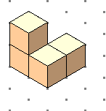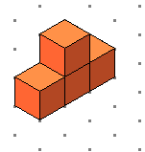

Activity 9: To make cubes and cuboids of given dimensions using unit cubes and to calculate volume of each.

- 4x3x2
- 3x3x3

Activity 10: To explore the relationship between
- Length (in cm) and perimeter (in cm)
- Length (in cm) and area (in cm²)
of 5 squares of different dimensions drawn on a squared paper.

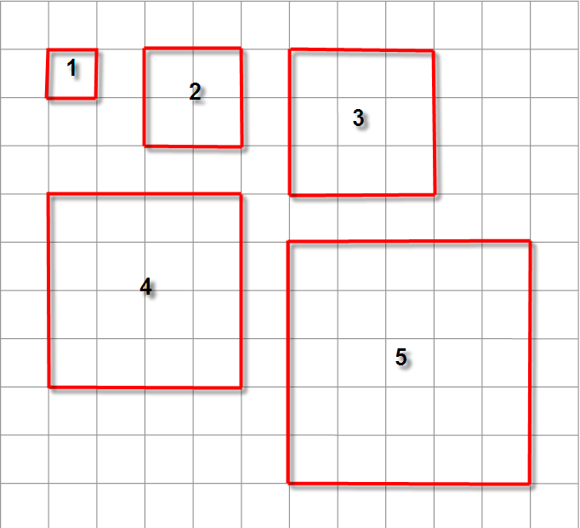
Length of a side (L) | Square 1 | Square 2 | Square 3 | Square 4 | Square 5
Perimeter (P)
Area (A)
P/L
A/L

List of materials for performing activities in Mathematics Lab

Grade – 3

- Dot paper
- Stickers
- 1m long thick thread
- Rectangular sheet of paper
- Shoe box
- Geometry box
- Dice
- Beads/Pebbles/ Coloured Counters
- Fake notes and coins
- Coloured paper/origami paper
- Glue

Grade – 4

- Dot paper
- Geometry box
- String of length 1 m
- Square piece of paper
- Rectangular piece of paper
- Coloured paper/ origami paper
- Pair of scissors
- Glue

Grade – 5

- Coloured paper/ origami paper
- Match sticks
- Circular paper (for degree clock and representation of fractions)
- Squared paper
- Rectangular strips of paper
- Unit cubes of dimension, 1x1x1
- Pair of scissors
- Glue

Grade-6

- Net of a cube
- Squared paper
- Coloured paper/ origami paper
- Grid paper
- Circular papers
- Rectangular paper
- Net of prism and pyramid
- Paper strips
- Coloured buttons/ counters
- Grid paper
- Cut-outs of equilateral triangle, isosceles triangle, square, rectangle, rhombus
- Plastic English alphabet set
- Pair of scissors
- Glue

Grade 7

- Coloured paper/ origami paper
- Pairs of angle cut-outs
- Pair of scissors
- Glue
- Triangular cut out
- Broom sticks
- Squared paper
- Circular cut-outs
- Grid paper
- Strips and slip
- Rectangular paper
- Squared paper
- Isometric Dot paper
- Unit cubes of dimension 1x1x1

Grade 8

- Coloured paper / origami paper
- Pair of scissors
- Glue
- Paper net of a dice
- Unit cubes of dimension 1x1x1
- Match box
- 3 containers with circular box of different radii
- Squared paper

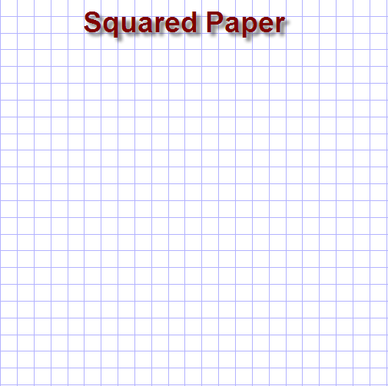

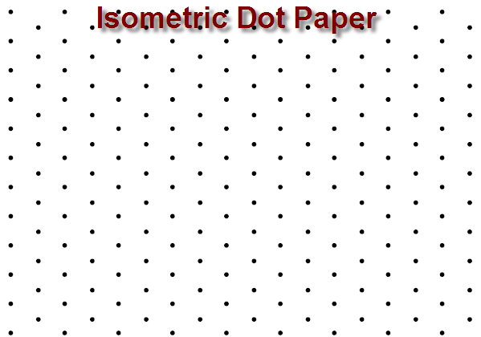

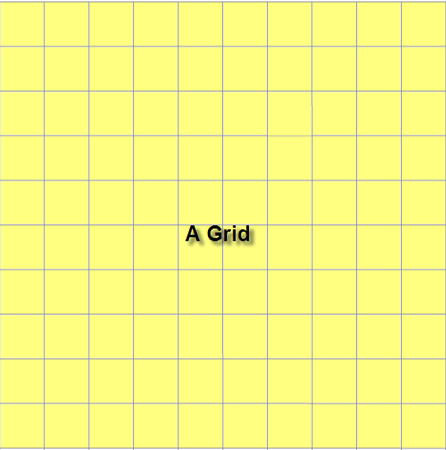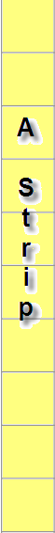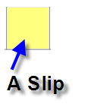

Net of a cube

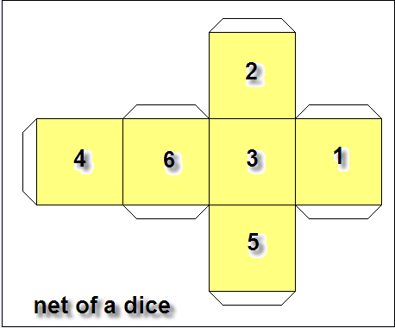

Tangram

Tangram on 8 X 8 Squared paper

